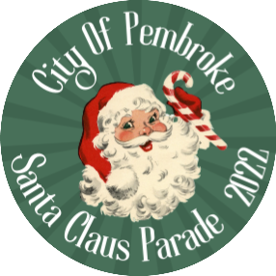
Annual Santa Claus Parade of Lights
SATURday, November 26TH, 2022
5:30 p.m Start

Theme: Retro Christmas
Please complete form and return to:
City of Pembroke Parks & Recreation Department
In Person: Pembroke Memorial Center Office
Phone: (613) 735-6821 ext. 1507
Mail: City of Pembroke, 1 Pembroke Street East,
Pembroke, ON K8A 3J5

Organization: __________________________________________________________________________________

Contact Name: _________________________________________________________________________________

Address: ______________________________________________________________________________________

City: ________________________Postal Code: ______________________

Phone Number: ___________________ Cell #________________Email: __________________________________

Website: ______________________________________________________________________________________

Number you can be reached at on the day of the parade: ____________________

Entry Type: Business ⁭ Non-profit organization ⁭ School ⁭ Church ⁭ Sports ⁭ Other: ____________________

Vehicles: Float ⁭ Car ⁭ Truck ⁭ Other: ____________________

Groups: Marching ⁭ Walking ⁭ Dancing ⁭

Animals: Yes ⁭ No ⁭ If yes, please describe what type and how many: ______________

Please note: ALL ENTRIES WITH ANIMALS REQUIRE A CLEAN UP PERSON TO ACCOMPANY THE ANIMAL AT ALL TIMES
INCLUDING THE START AND FINISH LOCATION.

Number of adults: _________________ Number of children: _____________________

Sound emitted*: No sound ⁭ Amplified music ⁭ * We recommend music on all floats

PLEASE HELP THE TELEVISION COMMENTATORS TALK ABOUT YOUR FLOAT!
Would you be interested in a pre-event story covered by YourTV (Cogeco) about your float? *: Yes ⁭ No ⁭
Registration must be received no later than November 4th to be considered for a pre-event story.

Float Description: _______________________________________________________________________________

______________________________________________________________________________________________

Description of Your Organization: ___________________________________________________________________

______________________________________________________________________________________________
NOTE: ALL ENTRIES MUST HAVE CHRISTMAS LIGHTS!
The City of Pembroke does not allow parade participants to disseminate any information that is generally considered to be contentious, controversial, or publicly divisive.

